Back Muscle Assessment
This is assessment is part of the assessment for the deep active system of the pelvis, trunk and lumbar spine. Use in conjuction with the abdominal wall and back muscle assessment.

Deep Back Muscles

Semispinalis
The semispinalis is the most superficial of the deep intrinsic muscles. Much like the intermediate muscles, it can be divided by its superior attachments into thoracic, cervicis and capitis.
https://teachmeanatomy.info/back/muscles/intrinsic
 | Origin | Thoracic attachment | Cervical attachment
Spinalis | TP C4 – T10, ascending 4-6 segments | SP of T1-4 | SP C2-C7 & occiput | Posterior rami of the spinal nerves

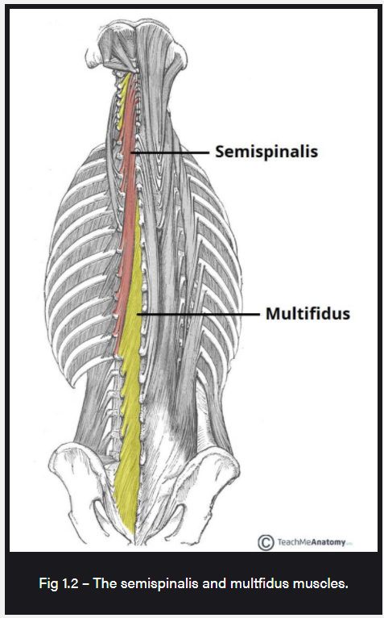

Multifidus
The following are excerpts from an article by Lonnmann et al 2008.
Lonnemann, M. E., Paris, S. V., & Gorniak, G. C. (2008). A morphological comparison of the human lumbar multifidus by chemical dissection. The Journal of manual & manipulative therapy, 16(4), E84–E92. https://doi.org/10.1179/jmt.2008.16.4.84E
The multifidus is the most medial paraspinal muscle lying over the zygaphophyseal joints and lateral to the spinous processes (SP) of the lumbar spine (Figure ​(Figure1).1). It is the largest paraspinal muscle to cross directly over the lumbosacral junction.
There is one muscle band at each of the five lumbar vertebral levels. Each band is divided into several fascicles that can be distinguished based on their caudal attachments. The deepest fascicles are the shortest and originate on the lamina. All the other fascicles arise from the SP and originate from a common tendon that attaches to the caudal and most dorsal aspect of the SP.
The laminar layer is made up of the deepest fascicles, which insert on the mamillary process of the vertebrae two levels caudally. The fascicles from the lateral surface of the SP insert onto the mamillary process of the vertebrae three levels caudal. The fascicles from the tubercle of the SP insert onto the mamillary processes of the vertebrae four and five levels caudal. Another long slender fascicle arises from the common tendon and inserts into the caudomedial aspect of the posterior superior iliac spine (PSIS). Some of the more superficial fibers arising from the common tendon attach to the deep surface of the erector spinae aponeurosis over the sacrum.
Bogduk et al14 have described the innervation of this muscle as unisegmental. Muscle fibers that attach to the vertebral body of L1 will be innervated by the L1 segment. In that study, the authors reported that the medial branch of the dorsal ramus supplies the fascicles that arise from the SP and lamina of the vertebrae with the same segmental number as the nerve. While some authors have supported this description, some discrepancies have been noted in the recent literature that question the concept of unisegmental innervations.
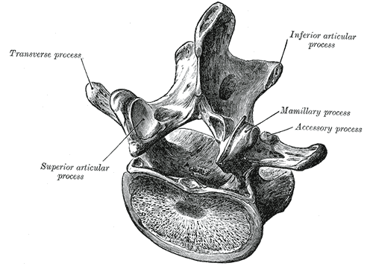

 | Origin | Insertion | Innervation
Deep Multifidus | The shortest and originate on the lamina of the lumbar vertebra. | mamillary process of the vertebrae two levels caudally | medial branch of the dorsal ramus supplies the fascicles that arise from the SP and lamina of the vertebrae with the same segmental number as the nerve.
Superficial Multifidus | SP of the lumbar vertebrae, originating from a common tendon caudal and most dorsal aspect of the SP. | Between 3 & 5 levels caudal to the vertebra, PSIS and ES aponeurosis (details below
Layer 2  (from bottom):  The fascicles from the lateral surface of the SP insert onto the mamillary process of the vertebrae three levels caudal. | Layer 3  (from bottom):  The fascicles from the tubercle of the SP insert onto the mamillary processes of the vertebrae four and five levels caudal. | Layer 4:  (2nd from top)  Another long slender fascicle arises from the common tendon and inserts into the caudomedial aspect of the posterior superior iliac spine (PSIS). | Layer 5:  (Most superficial)  Some of the more superficial fibers arising from the common tendon attach to the deep surface of the erector spinae aponeurosis over the sacrum.

Multifidus Layers

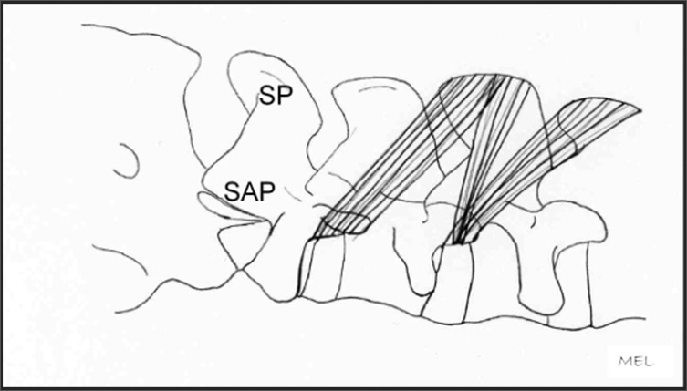
FIGURE 4
Superficial layer: SP=Spinous Process, SAP=Superior Articular Process.

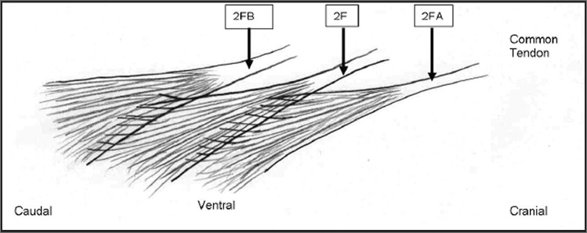
FIGURE 6
Fascicles of the second layer of the multifidus.
2F=Tendon and fascicle of second layer originating from L2 spinous process.
2FA=Tendon and fascicle of second layer originating from L1 spinous process. Fascicles from 2FA interdigitate with fascicle 2F.
2FB=Tendon and fascicle of second layer originating from L3 spinous process receiving fascicles from 2F.
Not pictured: Interdigitation of muscle fibers to the layer ventral to the second layer or 3F fascicles.

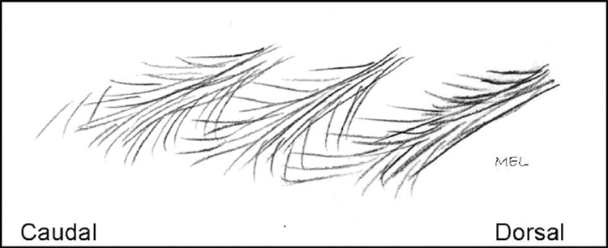
FIGURE 9
Layer 3 fascicles interdigitating with fascicles above and below.

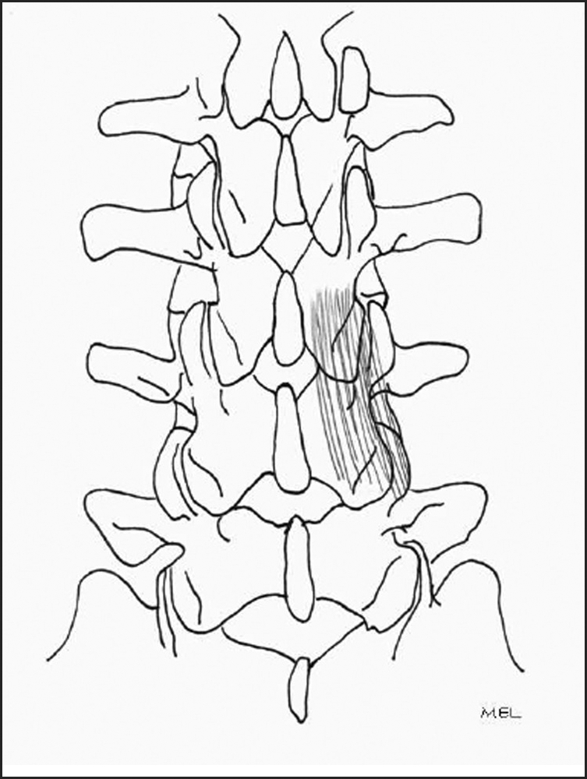

FIGURE 12
Fourth layer. Interlaminar fibers.

Multifidus on US
Ultrasound is a reliable and valid tool for measuring multifidus contraction (Wong et al 2013). On US, multifidus will appear as two layers. Palpate and place probe just lateral to the SP and medial to the ES muscle group. The transverse processes will appear as a “loch ness monster” – the black shadows created by the TP bone create the appearance of monsters legs.
Place the probe longitudinally (curvilinear) and determine response of MF to a cue. As with TrA, seeing activation of the deeper fibres without overactivation of the superficial fibres is the ideal outcome.

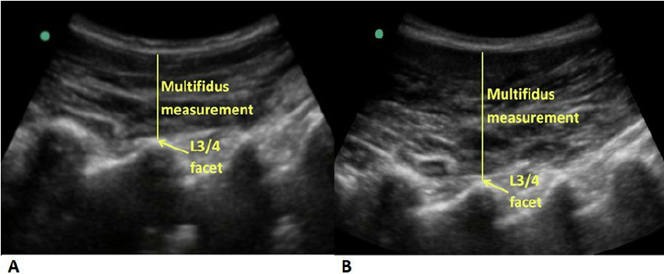

Image:
Wong, Arnold & Parent, Eric & Kawchuk, Greg. (2013). Reliability of 2 Ultrasonic Imaging Analysis Methods in Quantifying Lumbar Multifidus Thickness. Journal of Orthopaedic and Sports Physical Therapy. 10.2519/jospt.2013.4478.

Superficial Back Muscles

Erector Spinae
I Love Spinach:
Iliocostalis
Longissimus
Spinalis

 | Origin | Thoracic attachment | Cervical attachment
Iliocostalis | common tendinous origin | costal angle of the ribs and the cervical transverse processes
Longissimus | common tendinous origin | The lower ribs,  TP T1-T12 | the transverse processes of C2 – C7 & mastoid process of skull
Spinalis | common tendinous origin | SP T1-T8 | SP of C2, & occipital bone of the skull. | Cervicis sometimes absent

Innervation: Posterior rami of the spinal nerves

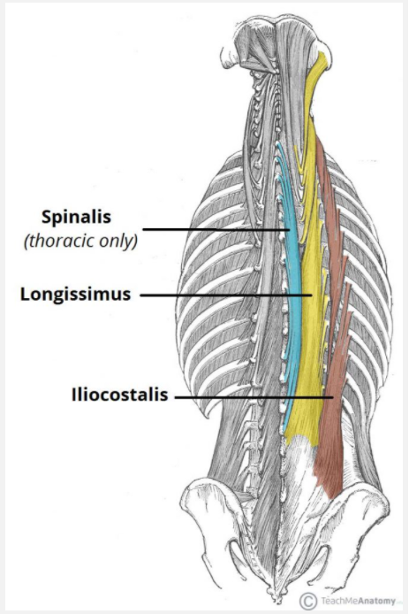
https://teachmeanatomy.info/back/muscles/intrinsic

Other Resources

https://www.sciencedirect.com/topics/neuroscience/multifidus-muscle
https://www.ncbi.nlm.nih.gov/pmc/articles/PMC2716159/

