Discharge Process

As part of Treatment Plan discharge patient from physiotherapy
Patient Cases (select the appropriate case) change to “discharged”

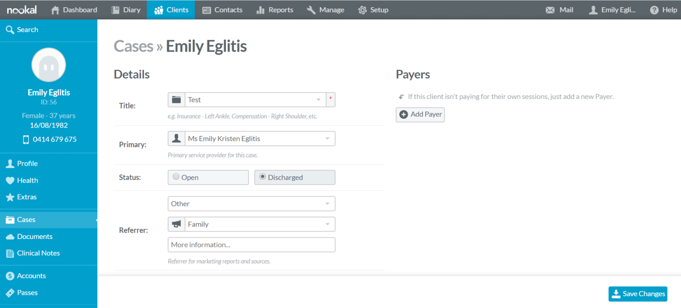

Discharge Tracking FOS
- To do on the first day of each month
- Run a report for each physiotherapist for discharges three months ago. i.e. on the first day of April, you will run a report for January 1 – 31.
- Reports Clinic Discharges
- Select date range
- Filter by provider
- Print and give to physio

Physiotherapist
- Review discharge list
- Follow-up phone call to each person – note in client file when completed – write one tick for this next to the client’s name
- Ensure GP letter has been sent for each person – note in client file when completed – write a second tick for this next to the client’s name
- Hand completed list to Practice Director for review

